Module 11-4

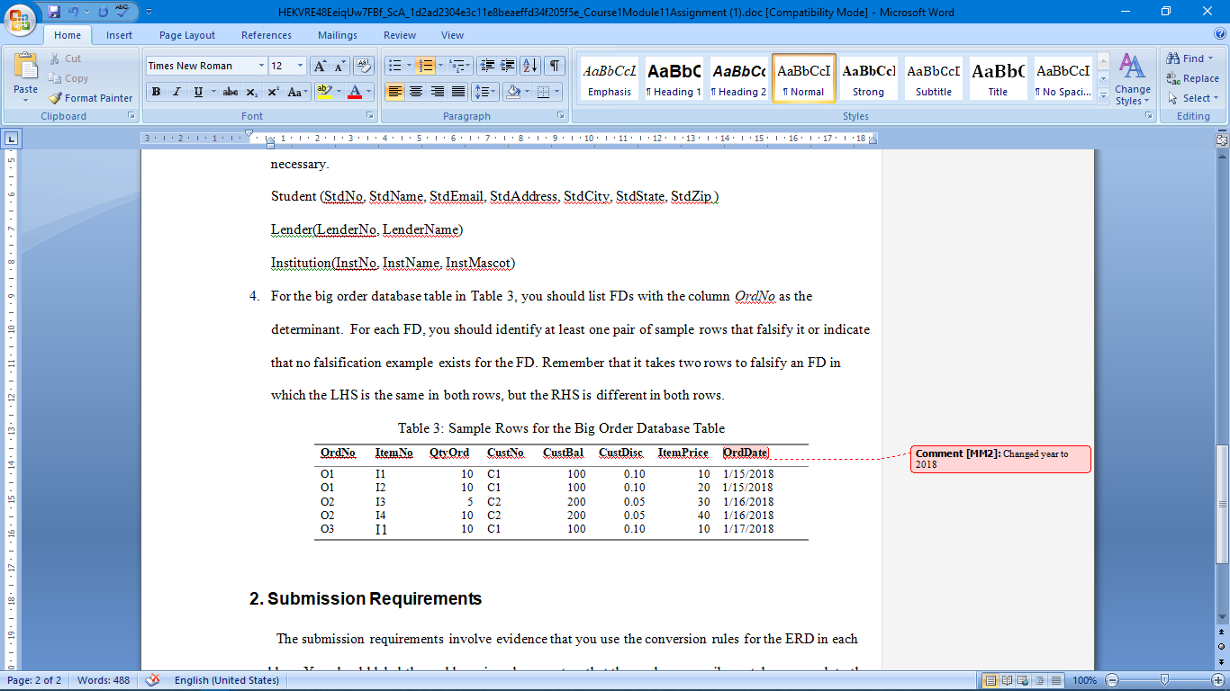

4)

|  |  |
| --- | --- |
| **FD** | **Falsification** |
| OrdNo -> ItemNo | (1,2) (3,4) |
| OrdNo -> OtyOrd | (3,4) |
| OrdNo -> CustNo | none |
| OrdNo -> CustBal | none |
| OrdNo -> CustDisc | none |
| OrdNo -> ItemPrice | (1,2) (3,4) |
| OrdNo -> OrdDate | none |